***Damodhar Reddy Munagala***

***Email :*** [*damodhar1863@hotmail.com*](mailto:damodhar1863@hotmail.com)***Mobile No :*** *+91-8919170931*

***Career Objective***

An enthusiastic programmer, looking for an opportunity where I can enhance and utilize my knowledge in contributing for organization growth.

Skills Profile

Technical

|  |  |
| --- | --- |
| **Operating System** | Linux, Windows |
| **Database** | SQL Server, Oracle |
| **Languages** | Python, Core Java |
| **Other** | Machine Learning, Data Analysis, Data Visualization, Web Crawling, Networking, Data Structures and Algorithms |

Professional Experience

|  |  |
| --- | --- |
| **Organization Name** | Cap Gemini India Pvt. Ltd. |
| **Project Name** | Identity Theft Protection |
| **Project Duration** | April 2018 – Till Date |
| **Role/Title** | Jr. Developer |
| **Project Description** | ITP Alerts is a Batch application for pulling alerts from vendor and process them to send real time alerts to end users as per user enrollment. |
| **Technology Stack** | Java, Spring Batch |

Internship Experience

|  |  |
| --- | --- |
| **Organization Name** | Hut Story |
| **Project Name** | Web Crawlers |
| **Project Duration** | June 2016 – August 2016 |
| **Role/Title** | Backend Developer |
| **Project Description** | As Developer, I built web crawlers that automates the process of scraping the data from different websites and created a well structured database with the scraped data which helped in populating the hutstory website. To avoid the reuse of data by others added water marks to the images at random positions in the images. |
| **Technology Stack** | Linux, Anaconda, Python, bs4, requests, selenium, scrapy |

Achievements

* Secured 3rd Prize in AI4Change - Hackathon 2K18
* Secured 72 global rank in a coding competition conducted by GeeksforGeeks
* Qualified for Level 2 in ACM-ICPC coding competition organized by IBM
* Microsoft Certified Professional in Querying Microsoft SQL Server 2012
* Microsoft Technology Associate in Networking Fundamentals
* Oracle Certified Java Developer

Summary of Projects

Identity Theft Protection April 2018 – Till Date

Jr. Developer

ITP Alerts is a Batch application for pulling alerts from vendor and process them to send real time alerts to end users as per user enrollment.

Summary of Internship

Web Crawlers June 2016 – August 2016

Backend Developer

Built some web crawlers to automate the process of scraping the data from the Internet, created a well structered database with the scraped data and used water marking to avoid reuse of the data using python.

AI4Change - Hackathon

Agro Crop – Price Prediction

Developer

Making accurate predictions for short-term market prices of agro-products, depending on the daily prices in wholesale markets, built an ANN model which consists of an interconnected group of artificial neurons, it is an adaptive system that changes its structure based on external or internal information that flows through the network.

The accuracy of ANN model is more than 90%

**Environmet:** Anaconda, Python, Tensorflow, Artificial Neural Networks

***Technical Certifications***



**OCA, Java SE 8 Programmer**

May 2018 - Present

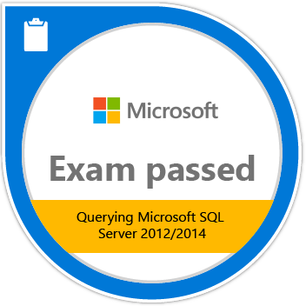

**MCPS: Microsoft Certified Professional**

Sep 2015 - Present

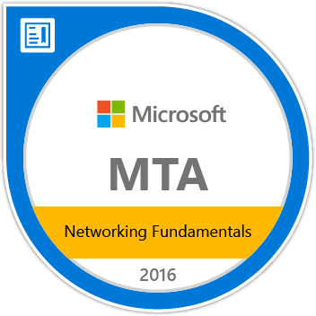

**MTA: Networking Fundamentals**

Jun 2015 - Present

Education

B. Tech Computer Science**,** Amity University, Gwalior, Madhya Pradesh, India, 2017.

***Personal Details***

Date of Birth : 16th January 1996

Languages Known : English, Telugu and Hindi

Address : Kurnool – Andhra Pradesh – India